Core Track Quality Assurance Process for

the Productive Use Financing Facility

Updated January 28, 2026

The Productive Use Financing Facility (the Facility) provides financial subsidies and technical assistance to companies that procure large quantities of high-quality and energy-efficient productive use equipment (PUE). To receive PUFF support, all PUE must be reviewed to ensure and verify energy performance, quality, and safety.
This document describes the quality assurance process for the Core Track: solar water pumps, refrigerators, and freezers. All other PUE technology categories should refer to the PUFF Quality Assurance & Testing Overview document.
To be eligible under the Core Track, Products must meet at least one of the following criteria:
- Be Winners or Finalists of the 2019, 2020, or 2022 Global LEAP Awards for solar water pumps or refrigerators; OR
- Have undergone VeraSol testing according to the relevant Global LEAP test methods, with performance benchmarked satisfactorily against minimum performance benchmarks established by the Administrator, informed by the lowest-performing Winner or Finalist in the same size or form factor category from the most recent Global LEAP Awards competition; OR
Applicants that have already met one of the Core Track eligibility pathways (e.g., Global LEAP Award recognition or completed VeraSol testing) should clearly indicate this in their application and provide the relevant documentation.
Applicants that have not yet met any of the eligibility pathways at the time of application must be prepared to initiate VeraSol testing in order to qualify for PUFF support. Testing must be completed within the timelines specified by the Administrator. Failure to initiate or complete testing in a timely manner may result in delayed contracting, reduced allocations, or ineligibility for funding. Note that the testing process can take between 10–22 weeks depending on the test lab’s capacity, shipping times, the complexity of the product, and other factors.

The Facility partners with VeraSol to test PUE and generate consistent and comparable performance data to confirm eligibility for financing support, fill critical information gaps, and inspire market competition. After testing, VeraSol will publish the results on the VeraSol Product Database, a tool investors, development programs, and companies use to source and verify the performance of off-grid appliances.
This document contains information on the process for companies or organizations that are interested in testing an off-grid appliance through VeraSol to qualify for support from the Facility. Please see Annex A for a complete checklist of steps. Once testing is completed, VeraSol acts as a third-party test results reviewer to verify data, share a product performance evaluation, and publish the data. If you would like to submit a product for testing, please review the below information, begin by contacting the appropriate test lab for a quotation, and reach out to us at testing@verasol.org if you have questions about the process.

Product Scope
VeraSol tests standalone fans, refrigerators, solar water pumps, electric pressure cookers, and nascent PUE that are intended for or compatible with off-grid energy systems (e.g., low-voltage DC systems, AC or DC mini-grids). The specific product sub-categories or other product requirements for testing under PUFF are listed below:

Product | Product Sub-Categories / Other Requirements
Refrigerators | Refrigerators, refrigerator-freezer combination units, freezers, multi-temperature cabinets, or solar direct drive refrigerators
Solar Water Pumps | Surface, submersible, or battery-integrated pumps

Steps for Testing an Off-Grid Appliance through VeraSol







Test lab outreach
Product sampling and shipping
Product testing
Review test results
Share results
Complete product information form

Step 1: Complete the VeraSol Product Information Form
Please complete VeraSol’s product information form to provide more detailed information about the product and its performance. Please download this once completed and share it with the test lab when reaching out for a quote.

Step 2: Coordinate with Test Lab and Receive Quotation
Companies should begin by reaching out to an approved test lab under the VeraSol test lab network (see Annex B) to inquire if the lab has testing capacity, receive a timeline estimate, and request a quote. Companies are responsible for coordinating with the lab for testing.

Step 3: Product Sampling & Shipping
Companies are required to randomly sample products to be tested with a third-party sampling agent. This is to eliminate preferential pre-selection bias of products and to ensure that the test data are representative of products from a commercial run. Companies will need to coordinate with the sampling agent to identify a time and date to conduct warehouse sampling, and then the agent will randomly select samples that will be shipped for testing.
Companies need to sample two units per model from a specified minimum stock for testing. Two samples are required to be sampled and shipped in case of damage during transportation, but only one sample will be tested. Please include the appliance, its user manual, and warranty information. If the product is sold with a PV module, you do not need to send the PV module.
The minimum stock requirement from which the two units will be selected depends on the product type:
- Refrigerators: Minimum stock of 20 units
- Solar water pumps: Minimum stock of 20 units

Please see Annex B for VeraSol-recommended sampling agencies. Companies can use an email template (see Annex C) to request random sampling. But VeraSol will accept random sampling reports from other third-party entities, if their reports include the required information below. The sampling reports must include:
- Name and contact information of the third-party entity
- Name and contact information of inspector who conducted the sampling
- Photographs of the minimum stock in the warehouse
- Photographs of the two randomly selected samples with documented serial numbers. Serial numbers ensure that the product that arrives at the lab is the same as the one that was sampled.
- Photographs of the selected samples packed up and sealed for shipping
Companies are required to share the sampling report with VeraSol so we can ensure that the process was followed appropriately. We recommend doing this prior to testing so as not to risk invalid test results.
After the products have been randomly sampled, companies are responsible for shipping product samples to the appropriate test lab. They will also need to inform the lab that they have shipped and provide tracking information. Please refer to our shipping guide for guidance on how to ship off-grid products.
For companies testing for the Facility, products must be sampled, shipped, and arrive at the appropriate test lab within three weeks of Facility application approval.

Step 4: Product Testing
Independent laboratory testing and evaluation assesses the extent to which products meet their advertised performance claims and measures the design elements that make them suitable for off-grid use. VeraSol coordinates and advises a global network of ISO-accredited test laboratories to test products. Testing is performed in accordance with the Global LEAP test methods for off-grid appliances:

- Global LEAP Off-Grid TV Test Method
- Global LEAP Off-Grid Fan Test Method
- Global LEAP Off-Grid Refrigerator Test Method
- Global LEAP Off-Grid Solar Water Pump Test Method
- Global LEAP Electric Pressure Cooker Test Method
- Rapid Product Assessment for Productive Use Appliances (please contact us for specific test method information)
Product testing can take between one to three months depending on the test lab’s capacity and the complexity of the product. Please see Annex D for a detailed timeline estimate.

Step 5: Test Results Review
Once testing has concluded, please instruct the test lab to send the test report to VeraSol and your company in tandem. During this time, VeraSol will review the results, follow up with the test lab if necessary, and evaluate whether the product meets the requirements to qualify for funding through the Facility. VeraSol will share the evaluation results with the company and the Facility team.
Companies testing for the Facility that receive negative testing results may either exit the program (if that's their only submitted product), forfeit funding for that product (if they have multiple submitted products), or they can work with us to find a different quality-assured product (though a subsidy for testing will only be available for initially submitted products).

Step 6: Data Sharing
VeraSol will upload the test results into the VeraSol Product Database, an interactive, open-access online database that allows users to easily view product data. Buyers and other market actors use this database to identify and source products.

Compliance
By participating in the Facility and submitting your product for VeraSol testing, your product may be randomly selected for follow-up testing at any time to guarantee continued quality. If significant discrepancies are identified in performance and quality between the samples provided for initial testing and any follow-up testing, future subsidies and participation in the Facility may be suspended.

Costs
Sampling, shipping, and testing costs will be borne by the company except where noted. The Facility offers a fixed testing subsidy of up to 25% per model (for up to 2 models per company) Please see the Facility Terms and Conditions. For more information on estimated costs associated with appliance testing, please see Annex B and reach out to the appropriate test lab for a detailed testing quote.
Annex A: Process Checklist
Pre-testing
- Complete VeraSol’s product information form and download completed form
- Reach out to appropriate test lab for quotation and share with them the completed VeraSol product information form
- Share any other product specifications with test lab

Sampling and Shipping
- Prepare minimum stock based on product type
- Reach out to third party sampling entity to request sampling service
- Pay sampling fee to sampling entity
- Share random sampling report with VeraSol prior to testing
- Ship randomly selected and packed samples to the appropriate test lab to arrive within three weeks of Facility application approval
- Let the test lab know the samples are on their way and provide tracking information
- Provide any additional product shipping information as needed (i.e., refrigerant recharging instructions)

Testing
- Pay testing fees in a timely manner to ensure no delay in testing
- Request that the test lab send the test report to VeraSol when testing is completed
- Receive test report in tandem with VeraSol from the test lab
- Receive VeraSol results summary and database listing

Annex B: Sampling Agent and Test Lab Information and Approximate Costs
Sampling Location | Lab Name | Contact | Phone | Email | Cost per Event (USD)
Global | Intertek Hong Kong | Angela Yu | +85296809312 | angela.yu@intertek.com | $350-$1,200
East Africa (Kenya, Uganda, Rwanda, Tanzania) | Kijani Testing | Kinya Kimathi | +254715539911 | kinya.kimathi@kijanitesting.com | $500-$2,000
West Africa | Cherrionics Nigeria Limited | Engr. Achema Cherry Alewu | +2348052312544 | achemaa@hotmail.com; gm.cherrionics@gmail.com | $150-$300+

Testing Service Provided | Lab Name | Contact | Phone | Email | Location | Cost per Product (USD)
Refrigerators and freezers | Re/genT | Patrick Beks | +31492476365 | patrick.beks@re-gent.nl | Helmond, Netherlands | $5,000-$7,000
Solar water pumps | Schatz Energy Research Center | Kaileigh Vincent-Frazier | +17078264307 | serclightinglab@gmail.com | Arcata, CA, USA | $6,000-$8,000

Annex C: Request Random Sampling Email Template
You can use the following template to request random product sampling from a third-party sampling entity. Fill in the table with your product’s information and provide information for how to bill for sampling.

Subject: Random Sampling Request for VeraSol Appliance Testing: [Your Company Name]

Body:

Dear [XX],

I hope you are well. My company, [company name], is pursuing appliance testing with VeraSol and would like to request random sampling of our [product type], [product name], at our warehouse in [location]. Please find all the necessary information below:

Product type
Brand name
Model number
Warehouse name
Warehouse address
Contact person at warehouse who will coordinate random sampling
Random sampling date range
Instructions | For each model, select 2 units from a minimum stock of 20 units (for refrigerators and SWPs).  Package the products with packing materials provided by warehouse but with sampling entity’s packing tape or sampling agent’s signature across the tape.

Please note that the invoice billing information for this sampling is:
[insert billing information here]

Please let me know if you have any questions. Thank you!

Annex D: Testing Process Estimated Timeline

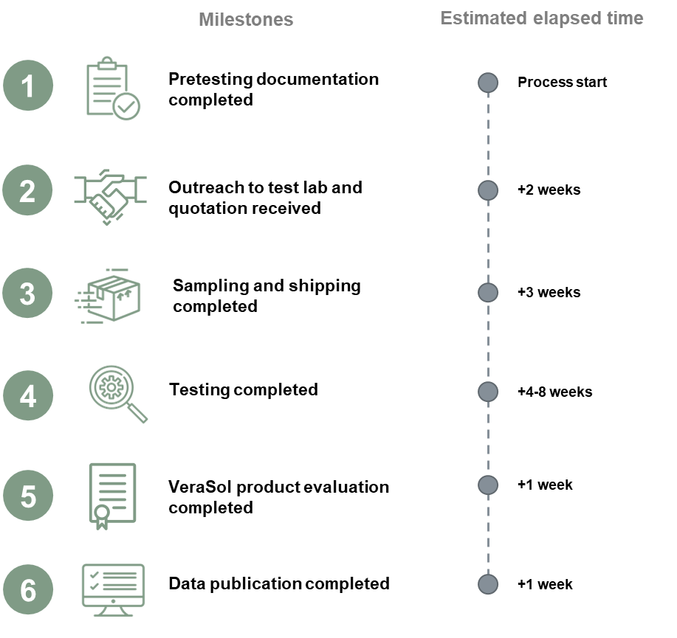
+4-12 weeks
+2 weeks

The pumps must also be intended for smallhold farmer or individual household use, designed to operate at a depth between 0 meters up to 140 meters, with the flow rate up to 350 liter per minute, and with a solar energy system capacity up to 2.4 kW.
Important information for refrigerators: Refrigerators should include appropriate refrigerants or should include instructions for recharging the type and amount of refrigerants if they are drained for shipping.
Important information for solar water pumps: Please sample and ship the controller.
Manufacturers of nascent productive use equipment are not required to do random sampling. They can simply ship the product directly to the lab and inform the lab of the tracking information.
Costs listed are approximate. Please reach out for an accurate quotation.
SWPs that require an alternative test method will incur additional testing costs that may be invoiced prior to test completion.

